Project Report: Society Management System

1. abdullah kamran 24k-0723
2. MUhammad 24k-0502
3. Hasan mujtaba 24k-0852

2024

Contents

1. Title 1

2. Introduction (Aim or Motivation) 1

3. Background (Research & Project Selection) 2

4. Project Specification 2

• Society Management 2

• Member Management 2

• Booking System: 2

• Suggestions: 2

• Data Persistence 2

5. Problem Analysis 2

6. Solution Design (Project Detail, Functionality, and Features) 2

• Add New Society: 2

• Delete Society: 2

• View Society Members: 2

• Add Society Members: 3

• Delete Society Members: 3

• Booking Venues: 3

• Cancel Bookings: 3

• View All Bookings: 3

• Suggestions: 3

7. Implementation & Testing 3

8. Project Breakdown Structure (Workload Distribution with Timeline) 3

9. Results (Output Screenshots) 3

10. Conclusion (Summary & Discussion) 5

# 1. Title

Society Management System

# 2. Introduction (Aim or Motivation)

The Society Management System is designed to facilitate the management of societies within an institution. It aims to streamline the processes of adding new societies, managing members, booking venues, and providing suggestions based on the department the person is already in. The motivation behind this project is to create an efficient platform that simplifies society management, enhances communication, and ensures the optimal utilization of resources within the institution.This software is to be set in One-Stop where the admin will process demands based on whoever comes to him.

# 3. Background (Research & Project Selection)

The project was selected based on the increasing need for effective management systems in educational institutions. Traditional methods of managing societies often lead to inefficiencies, miscommunication, and resource wastage. It became evident that a digital solution could improve the overall management of societies and their activities. This project combines principles of software engineering, user interface design, and database management to create a cohesive system.Digitally storing data can be effective as management can access the data anywhere and don’t need Members or society heads to inform them of everything, Making the data more consistent and making work more efficient.

# 4. Project Specification

The Society Management System includes the following specifications:

* Society Management: Add, delete, and view societies.
* Member Management: Add and delete members within societies.
* Booking System: Book venues for society events, check availability, and cancel bookings.
* Suggestions: Provide suggestions for societies based on user-defined fields of interest.
* Data Persistence: Store society and booking information in binary files for retrieval and manipulation.

# 5. Problem Analysis

The primary issues addressed by the Society Management System include:

* Inefficient tracking of society members and their details.
* Difficulty in booking venues and managing schedules.
* Lack of a centralized system for managing societies and their activities.
* The need for a user-friendly interface to simplify interactions with the system.
* A comprehensive solution that addresses multiple problems in one convenient place(One-Stop)

# 6. Solution Design (Project Detail, Functionality, and Features)

The system is designed with a console-based interface that allows users to interact with various functionalities. The main features include:

* Add New Society: Users can input society details, including name, field, and members.
* Delete Society: Users can remove a society and its associated data.
* View Society Members: Users can see the members associated with a specific society.
* Add Society Members: Users can add members into existing societies.
* Delete Society Members: Members can be Deleted if they are no longer in the society.
* Booking Venues: Users can book venues for events, ensuring no double bookings occur.
* Cancel Bookings: Users can cancel existing bookings.
* View All Bookings: Users can view all current bookings for transparency.
* Suggestions: Users can receive suggestions for societies based on their field of interest.

# 7. Implementation & Testing

The implementation of the Society Management System was done using C programming language. The system utilizes structures to represent societies, members, and bookings. File handling is employed to ensure data persistence. Testing involved:

* Unit testing for individual functions (e.g., adding societies, booking venues).
* Integration testing to ensure that all components work together seamlessly.

# 8. Project Breakdown Structure (Workload Distribution with Timeline)

| Description | Duration |

| Understand The different Modules we were going to include and making functions for each one | 1 week |

| Start working on each module( completed 4 to 5 modules| 1 week |

| Another 4 modules this week | 1 week |

| Finish the rest of the modules | 1 week |

| final testing and validation for all modules | 1 week |

| more testing and validation and report for the project| 1 week |

# 9. Results (Output Screenshots)

**Main Menu:**

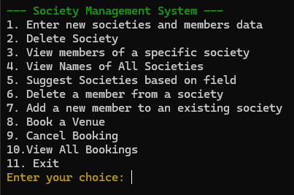

**View all Societies:**

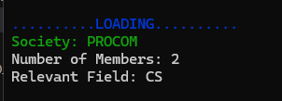

**Booking:**

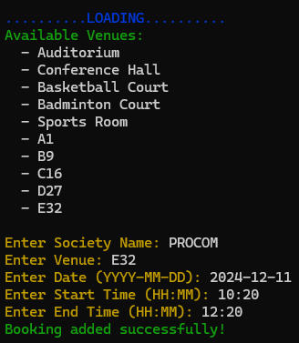

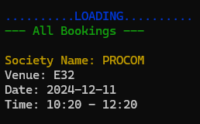

**Deleting member from existing society:**

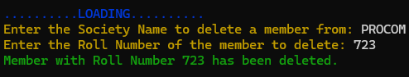

# 10. Conclusion (Summary & Discussion)

The Society Management System successfully addresses the management challenges faced by societies within educational institutions. It provides a user-friendly interface for managing societies, members, and venue bookings, ensuring efficient operation. The project demonstrated the importance of software solutions in enhancing organizational efficiency. Future enhancements could include a graphical user interface (GUI) and web-based access to further improve user experience and accessibility.